- Purpose
  - The purpose of this document is to describe the procedure for assembling the Inner Electrical Panel on the Genesys 20 Machine.
- Scope
  - This SOP applies to all equipment assembly team members. The process applies to the following machine ID’s:
EP50343EQS0600BE1200 – Inner Electrical Panel, G20 TR Disk
EP50344EQS0600BE1200 – Inner Electrical Panel, G20 TR ORB
EP50345EQS0600BE1200 – Inner Electrical Panel, G20 PA
- Responsibilities
  - The operations manager/supervisor is responsible for enforcing this SOP.
- Materials
  - The proper materials needed for this process are listed on the machine work order.
- Definitions

- Procedure
  - Start with an Inner Electrical Panel (E28891).

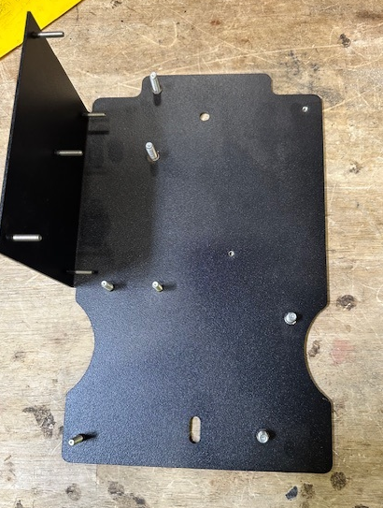

  - Add red Loctite onto the standoff threads.

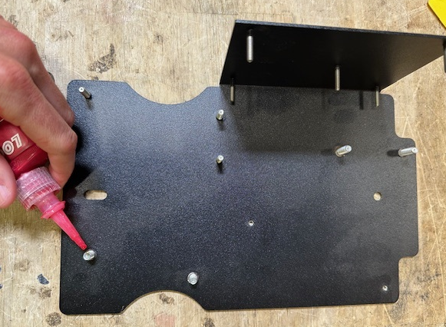

  - Attach an electrical standoff (E28950) to each stud and snug it in place. Be careful to not overtighten. Put some red Loctite onto a set screw (E29447) and thread it into the standoff. Repeat for the other standoff.

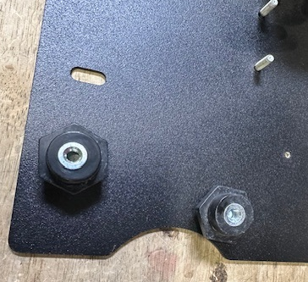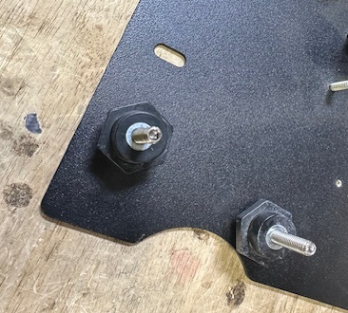
  - Place a spacer (E29373) over each of the 5 studs where the control board mounts.

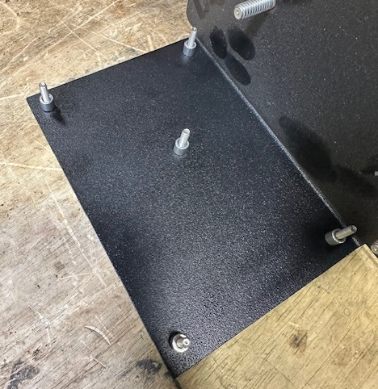

  - Attach a control board (E28892 for a Transaxle Units / E28810 for a pad assist unit) onto the 5 studs using 4 lock nuts (E29381). Do not put a nut on the center stud.

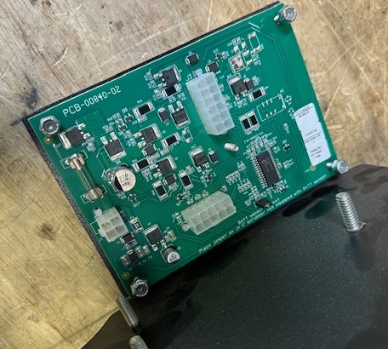
Don’t put a nut on center stud
- References (optional section as needed)

- Training Guide

Functional Training Groups Requiring Training
Equipment Assembly Group

- SOP Change Control

Date of Change | Reason for Change
TBD | This is the first version of the S.O.P. hence there are no revisions to this document.

Approvals

Submitter/Author Approval:__________________________________ Date:______________________

Management Approval:______________________________________ Date:______________________

QAU Approval:_____________________________________________ Date:______________________

